DIGITAL SERVICES AGREEMENT
Prepared by Defynd Marketing

1. THE PARTIES
This Digital Services Agreement (the "Agreement") is entered into and made effective as of May 21, 2026, by and between:
- The Service Provider: Defynd Marketing, represented by its authorized representative, with contact email defyndmarketing@gmail.com and telephone number +27 64 683 6357 (hereinafter referred to as the "Developer").
- The Client: Hardstyle Strength & Fitness, represented by Irfaan, located at 11 Islamabad Ave, Lenasia, 1827, with contact number 072 282 4889 (hereinafter referred to as the "Client").

2. SCOPE OF WORK
The Developer agrees to design and develop a single-page, mobile-responsive website for the Client based on the approved project structure. The scope includes the following components:
- Hero Section: High-impact dark athletic aesthetic displaying the business name, "Forget Your Troubles" tagline, and a primary "Start Your Journey" Call to Action (CTA).
- Why Hardstyle Section: Highlighting professional training value (Coach Irfaan), the unique high-energy community gym vibe, and results-driven transformations.
- Testimonials Area: Integration of verified 5-star customer feedback from Google Maps.
- Footer & Integration: Display of operating hours, map coordinates, and interactive "Call Now" / "WhatsApp to Join" floating action hooks for mobile devices.

3. FEES AND PAYMENT TERMS
The Client agrees to compensate the Developer for services rendered under the following financial schedule:
Service Component | Pricing Structure | Payment Terms / Due Date
Initial Website Development Fee | R2,000.00 (ZAR) | Fixed upfront cost. Payable immediately prior to the commencement of design and development works.
Monthly Administration & Maintenance Fee | R750.00 (ZAR) per month | Recurring fee. First payment due upon project handover, billed monthly in advance for hosting, upkeep, and basic structural administration.

4. PROJECT LIFECYCLE & REVISIONS
- Content Delivery: The Client is responsible for supplying all finalized textual content, accurate brand information, and media assets necessary to populate the design.
- Revision Windows: The development fee encompasses up to two (2) design review iterations based on the initial framework. Substantial structural changes requested beyond these iterations may incur extra hourly fees.

5. WORK PAUSE & TERMINATION CONDITIONS
- Payment Failures & Grace Period: In the event that recurring monthly administration fees remain unpaid for longer than three (3) business days past the invoice due date, the Developer reserves the right to immediately pause work, deactivate the live web assets, or suspend hosting services until accounts are fully cleared.
- Agreement Cancellation: Either party may cancel the recurring maintenance portion of this agreement by issuing a formal thirty (30) day written notice via email to the counterpart's registered communication address. Upfront development fees remain non-refundable once construction milestones are initiated.
- Code Handover & Server Removal Protocol: Upon formal termination of this agreement and settlement of any remaining outstanding fees, the Developer will execute a complete handover of all compiled website source code and associated design assets to the Client. Simultaneously, all files, databases, and structural hosting elements associated with the project will be permanently removed and scrubbed from the Developer's servers.

6. SIGNATURES & ACCEPTANCE
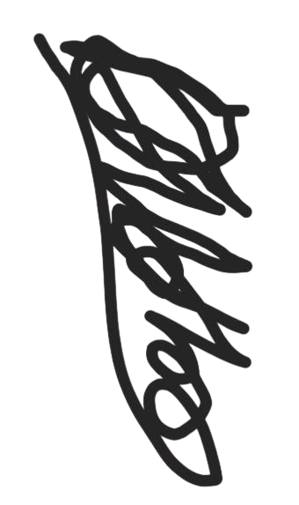
By signing below or issuing written authorization to proceed along with the initial deposit, both parties indicate their explicit acceptance of the terms, scope, and rates outlined in this document.
For: Defynd Marketing

Authorized Representative: ____________________
Date: 2026-05-21
For: Hardstyle Strength & Fitness

Client / Authorized Representative: ____________________
Date: ____________________

